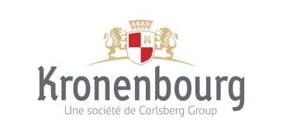

Press release

Paris, 9 June 2022

**InVivo and Kronenbourg SAS**

**launch the first traced Responsible Barley chain in France**

***In order to meet common sustainable development challenges and take action to support agro-ecological transition, Kronenbourg SAS, Malteries Soufflet and Soufflet Agriculture have combined their expertise to co-create the first Responsible Barley chain in France.***

***From 2023 onwards, 1664 Blonde will be brewed with almost 20% of its malt from this chain, gradually reaching 100% by 2026. In doing this, Kronenbourg SAS is establishing itself as a committed and responsible French brewer.***

**A unique and pioneering approach by a French brewer**

This unique and pioneering approach, carried out in partnership with Malteries Soufflet and Soufflet Agriculture, places Kronenbourg SAS on a large-scale and engaging transformation path.

This is an ambitious commitment from the French brewer, which is participating in the fight against global warming and the preservation of the environment and water resources, showing the way for the entire sector.

This Responsible Barley chain is part of the *“Sowing Good Sense”* approach, supported by the InVivo Group, which promotes productions from sustainable supply chains with minimum impact on the environment among its partner farmers.

Participating in the transition of the French agricultural model, this progress approach helps to reinforce the sustainability of the production sectors and works to guarantee valued and long-lasting outlets that meet consumers' expectations.

**An ambitious set of specifications to guarantee the sustainability and traceability of this Responsible Barley chain**

Malteries Soufflet, Soufflet Agriculture and Kronenbourg SAS have worked together to draw up specifications guaranteeing transitional agriculture with good agro-ecological practices by farmers. It ensures that a high level of quality is maintained in the malts and serves to:

* **Preserve the environment** and in particular promote biodiversity, especially through the good management of agro-ecological zones which helps maintain a rich and varied fauna and flora, the promotion of diversified crop rotation or the respect for good practices of natural predation and wildlife-friendly harvesting.
* **Promote a reduction in carbon footprint** through rational fertilisation based on annual soil analyses, or by encouraging carbon capture and biomass production through multi-species plant cover sown between crops.
* **Guarantee fair remuneration for partner farmers and valued outlets** via a premium rewarding the implementation of the commitments of this sustainable agricultural sector.
* **Ensure optimal quality** by selecting the best barley varieties and following good practices during malting, in order to contribute to a high brewing and aromatic quality.
* **Guarantee transparency on the French origin and responsible production conditions** from the field to the brewer, using blockchain technology.

The good agricultural and environmental practices implemented in this traced Responsible Barley chain are subject to external and independent control.

From the first year in 2022, the Responsible Barley chain has brought together 45 partner farmers, located in the Grand Est and Burgundy regions, mainly in the Aube and Yonne departments, with a production target of 900 hectares of traced Responsible Barley.

“*We are delighted to stand alongside Kronenbourg SAS in this industry initiative, which promotes agro-ecological practices. As a committed maltster, Malteries Soufflet has always ensured the issues of all the players, from the farmer to the consumer, are the main concern in any action it takes. In this way, we enhance the value of farmers' products while developing sustainable practices, in order to better meet our customers' expectations”, explains Guillaume Couture, CEO of Malteries Soufflet.*

**Kronenbourg SAS, a responsible and committed French brewer through its 1664 brand**

Carefully selecting raw materials and favouring local supplies, the 1664 Master Brewers rely on their brewing know-how to innovate and offer new beer-tasting experiences. It is therefore quite natural that Kronenbourg SAS, through its 1664 brand, which represents about 10% of the total beer consumed in France(1), has embarked on this innovative transitional farming approach and has applied it to its 1664 Blonde beer, brewed in Alsace at Obernai.

As a result, from 2023 onwards 1664 Blonde beer will be brewed with 20% of its barley from responsible agro-ecological practices, gradually reaching 100% in 2026, based on the production of 5,000 hectares of barley, with 250 farmers involved.

*“We are extremely proud to announce the launch of this Responsible Barley chain. This strong and engaging approach, developed with our partners Malteries Soufflet and Soufflet Agriculture, is part of Kronenbourg's long tradition of prioritising the environmental and social impacts of its activities. It also illustrates our passion for the art of brewing and for innovation”,* explains Anders Roed, CEO of Kronenbourg SAS.

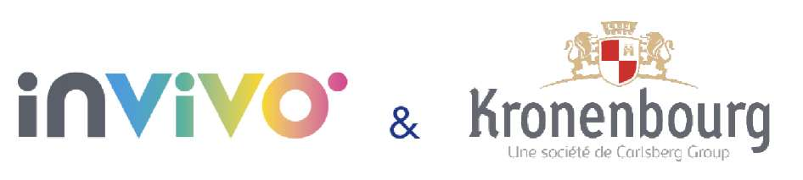

**About Soufflet Agriculture**

As a pioneer of traceable supply chains and the driving force behind their continuous development for some twenty years, Soufflet Agriculture supports farmers in implementing specific production specifications by providing expert agronomic advice, ensuring collection and guaranteeing valued outlets.

**About Malteries Soufflet**

Malteries Soufflet supplies high-quality malts to its brewing customers around the world. Its recognised mastery of the chain from grain to beer, its international presence, and its ability to meet customer needs make it a preferred partner, particularly in the development of approaches that combine quality and sustainability.

**About InVivo**

The InVivo Group, with the recent acquisition of the Soufflet Group, is one of Europe's leading agricultural groups, with a turnover of almost €10 billion, more than half of which is generated in France, and a workforce of more than 13,000 employees, including more than 10,000 in France. Established in 38 countries, it has more than 90 industrial sites, including 63 in France.

This key figure in food sovereignty operates along the entire value chain, from farm to fork, in each of its strategic business lines: Agriculture; Malting; Milling, ingredients, baked goods; Garden centre and food distribution; International grain trade; Wine.

A cross-functional global centre for innovative and digital solutions completes the system for accelerating the transformation of these activities towards the third agricultural revolution.

For more information: invivo-group.com / Twitter @InVivoGroup

**About Kronenbourg SAS, French brewer for over 350 years**

A French subsidiary of the Carlsberg Group since 2008 and a brewer in Alsace since 1664, Kronenbourg is the leading French brewer.

We produce 700 million litres of beer per year in France's largest brewery in Obernai (Bas-Rhin) and hold 30% of the market through a portfolio of diversified brands: Kronenbourg (the big name in beer in France), 1664 (the best-selling French beer in the world), Grimbergen (the most popular speciality beer), Carlsberg (the big international brand), SkØll Tuborg (the trendy beer), Tourtel Twist (a beer-based drink made from 0.0% alcohol with fruit juice), etc.

Kronenbourg is represented by more than 1000 beer enthusiasts. Excellence Brassicole® (Brewing Excellence), Innovation Partagée® (Shared Innovation) and Responsabilité Solidaire® (Joint and Several Liability): it is around these 3 areas that our company has been built and continues to develop over the 350 years of its existence.

(1): source IRI volume GMS year 2021

**Press contacts**

Krystel Valaydon, InVivo Group, [kvalaydon@invivo-group.com](mailto:kvalaydon@invivo-group.com) +33 (0)6 78 06 23 21

Jean-Pierre Tuil, Image et Entreprise, [jptuil@image-et-entreprise.com](mailto:jptuil@image-et-entreprise.com) +33 (0)6 81 47 12 48

ALCOHOL ABUSE IS DANGEROUS FOR YOUR HEALTH, CONSUME IN MODERATION